Chem 142 Quiz 2 Spring 2015

Name________________________KEY____________________ Instructor: Martin Larter

- The gas phase decomposition of NO₂ to form NO and O₂ was studied at 383°C and the following data was collected.

Time (s) | [NO₂],M | ln[NO₂] | 1/[NO₂], M⁻¹
0.0 | 0.100 | -2.30258509299 | 10
5.0 | 0.017 | -4.07454193493 | 58.8235294118
10.0 | 0.0090 | -4.71053070165 | 111.111111111
15.0 | 0.0062 | -5.08320598693 | 161.290322581
20.0 | 0.0047 | -5.36019277027 | 212.765957447

- Graph the data and determine the order of this reaction with respect to [NO₂] and calculate the rate constant.

- Calculate, using the appropriate equation, the time required for the [NO2] to reach 0.00037 M
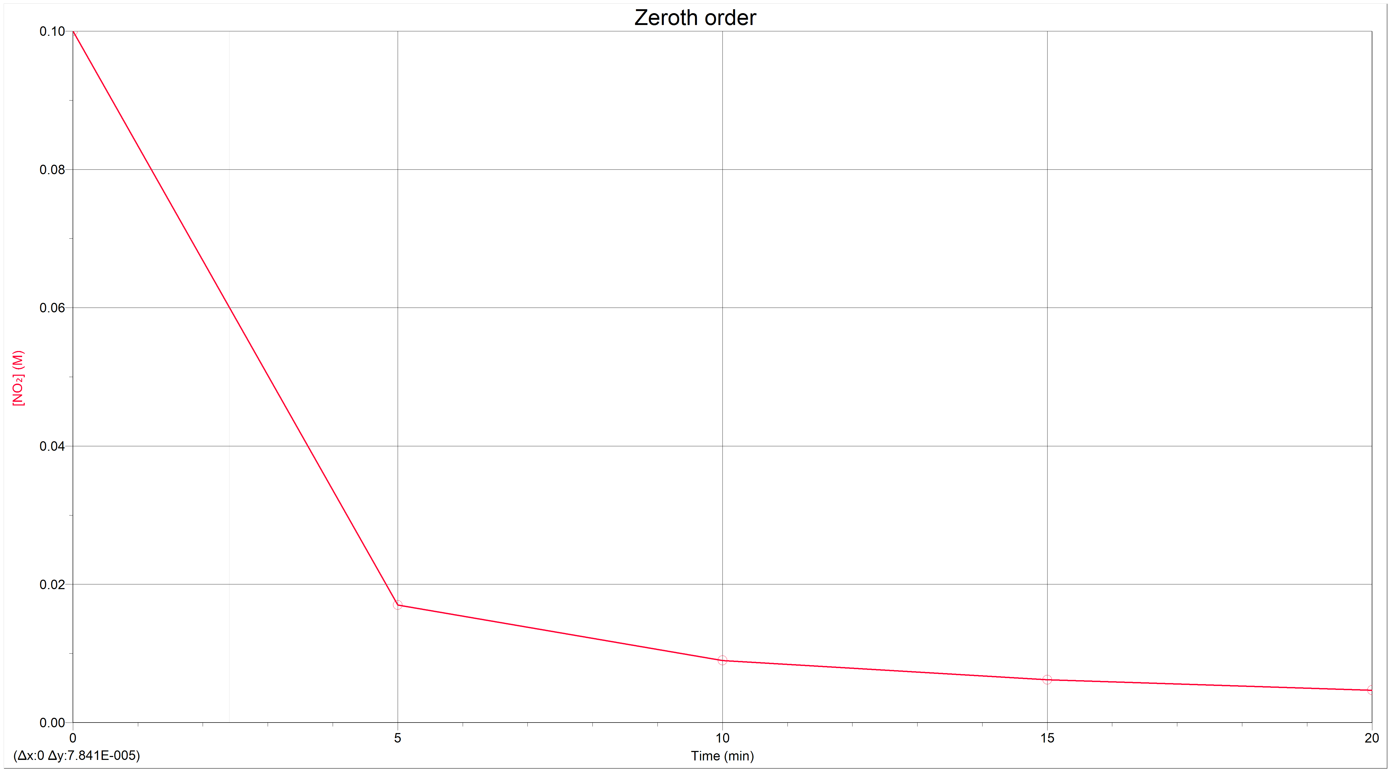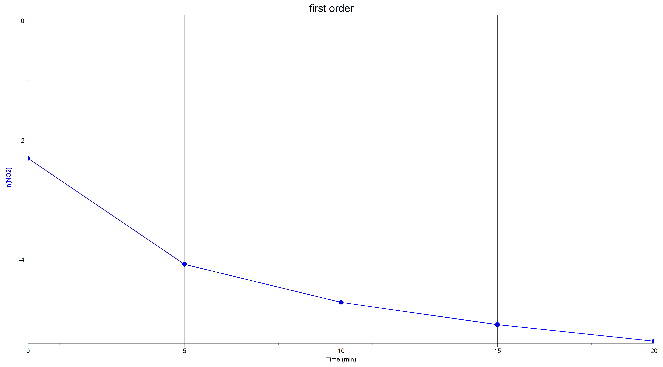

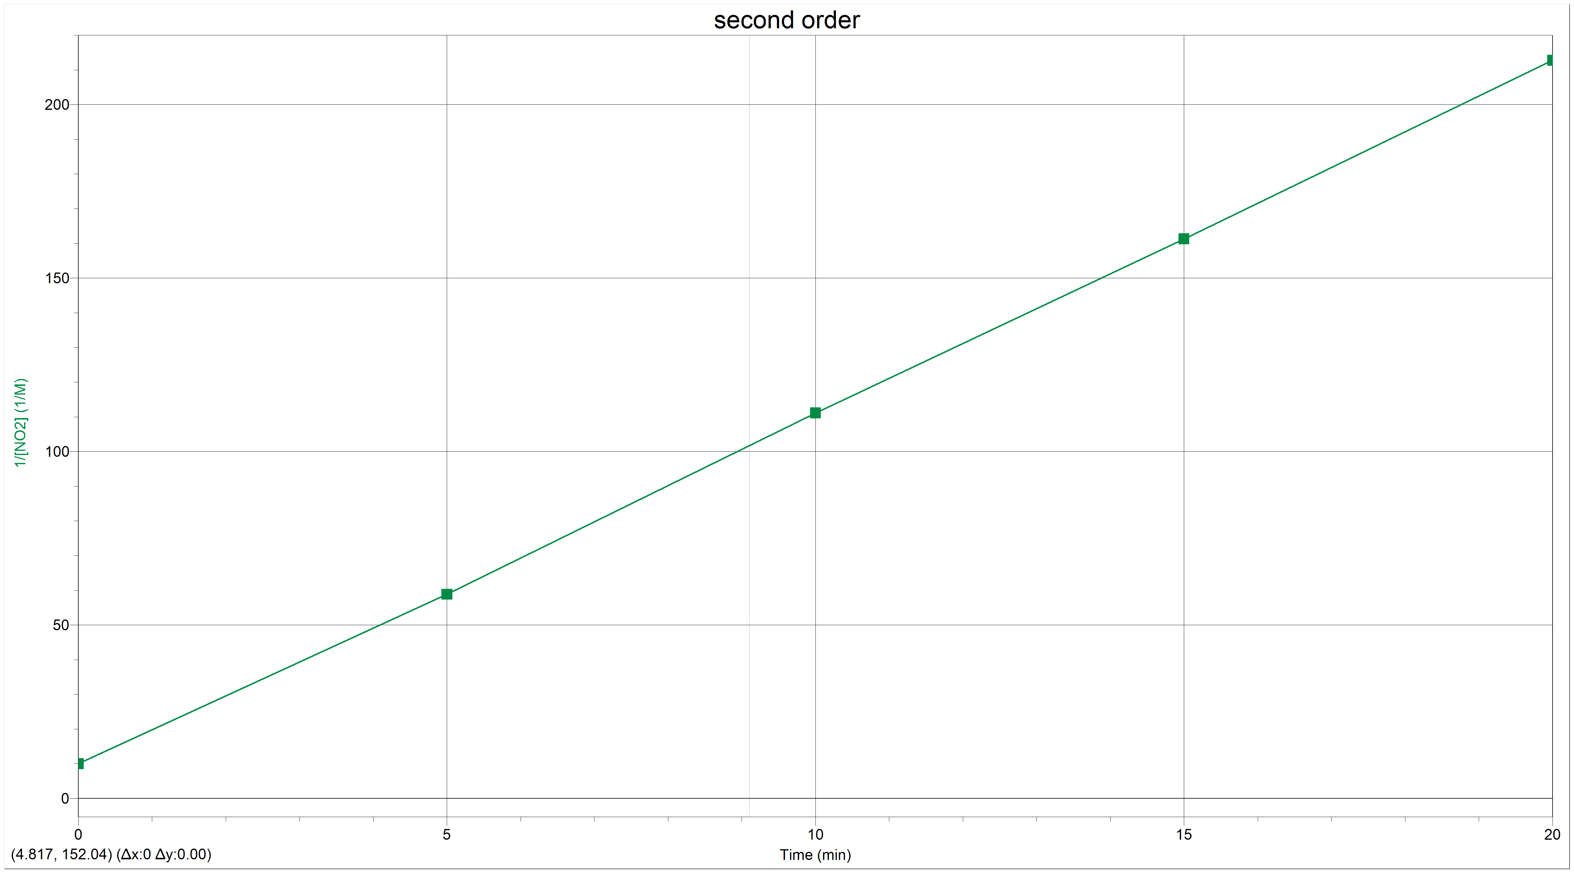

Second order reaction $\frac{1}{{\left[A\right]}_{t}}= \frac{1}{{\left[A\right]}_{0}}+kt$

$$K=\frac{212.8 M^{-1}-10{.0 M}^{-1}}{20.0\min{- 0.0 min}}=10.1M^{-1}\min^{-1}$$

$$\frac{1}{{\left[0.00037 M\right]}_{t}}= \frac{1}{{\left[0.100 M\right]}_{0}}+10.1M^{-1}\min^{-1}× t$$

$$t=270. sec$$

- Chemists commonly use the rule of thumb that an increase of 10 K in temperature doubles the rate of a reaction. What must the activation energy be for this statement to be true for a temperature increase from 25 ̊C to 35 ̊C?

$$ln\left(\frac{k_{2}}{k_{1}}\right) = \frac{E_{a}}{R} \left(\frac{1}{T_{1}}- \frac{1}{T_{2}}\right)$$
$$k_{2}=2k_{1}$$

$$ln\left(\frac{2k_{1}}{k_{1}}\right) = \frac{E_{a}}{8.314 \frac{J}{mol K}} \left(\frac{1}{298.15 K}- \frac{1}{308.15 K}\right)$$
$E_{a}=\frac{\left[\left(0.693\right)\left(8.315\right)\frac{J}{mol K}\right] }{\left(1.08 ×{10}^{-4} K^{-1}\right)}=53354 J=53.3 kJ$

In the reaction:

A (g) + B(g) C (g) + D (g) ΔH _{reaction}= -10.0 kJ

- Describe two factors that determine whether a collision between A and B results in a reaction

- The kinetic energy of the molecules - A certain minimum energy must be available for a reaction to occur. (Activation energy)
- The orientation of the molecules relative to one another - Even very energetic collisions may not lead to a reaction if the molecules are not oriented properly.

- How would a decrease in temperature affect the rate of the reaction shown above? Explain your answer

- A decrease in temperature would decrease the rate.
- Fewer molecules would have the energy necessary for reaction (fewer effective collisions).

- Explain why a catalyst increases the rate of reaction but does not change the value of the equilibrium constant for that reaction.

- A catalyst increases the rate by providing an alternate pathway that has a lower activation energy.
- The value of the equilibrium constant does not change, since a catalyst does not affect the energies (or concentrations) of the reactants and products.

